**Module-3: Docker – I Assignment – 5**

**● Create a sample HTML file.**

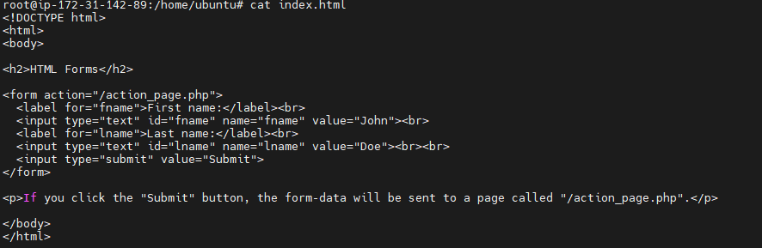

● Use the Docker file from the previous task.

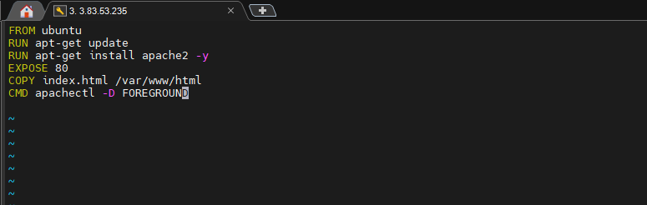

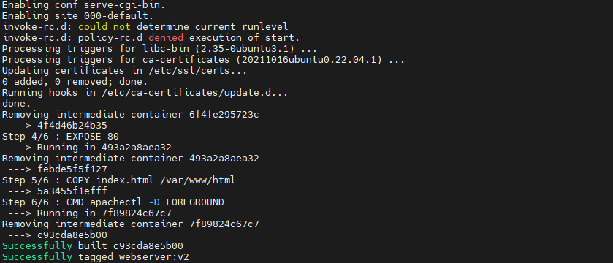

**● Replace this sample HTML file inside the docker container with the default page.**

